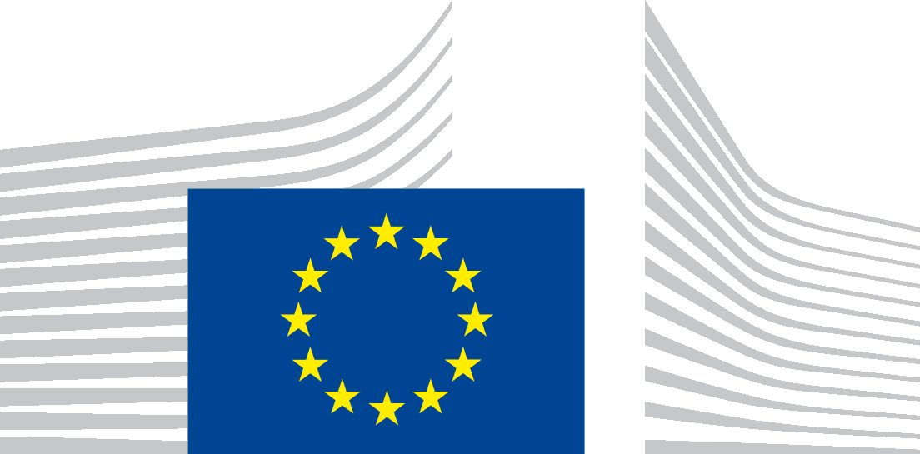 | EUROPEAN COMMISSION  DIRECTORATE-GENERAL JUSTICE and CONSUMERS  Directorate E: Consumers  Unit E.1 : Consumer Policy

Brussels, 3 March 2017

Annex - State of play of main files of relevance for the ECCG

Digital contracts proposal
Under the Slovak Presidency, the proposal for a Digital Content Directive was subject to a policy debate at the Justice and Home Affairs (JHA) Council of 8 December 2016. The Maltese Presidency aims for a general approach in June 2017. In the European Parliament (EP), the joint JURI/IMCO Committee will vote on the co-rapporteurs' report in May 2017. If both EP and Council are able to find the necessary compromises in determining their positions, trilogues, possibly leading to a first reading adoption, could start under the Estonian Presidency.
In the EP, the IMCO committee will vote on the rapporteur's report on the Online Sales of Goods proposal in June 2017. The rapporteur's draft report suggests an extension of the scope of the proposal to all sales of goods. In the Council, discussions have not yet started, as some Member States insist on waiting for the publication of the overall REFIT results. The Maltese Presidency aims for a policy debate on this proposal at the June JHA Council.

REFIT/Fitness Check of consumer and marketing law
The REFIT Fitness Check of EU consumer and marketing law and the evaluation of the Consumer Rights Directive are progressing. The Commission plans to publish the final reports by the end of May 2017.

Review of the Consumer Protection Cooperation Regulation
The Council adopted a General Approach text on 20 February. A vote in IMCO (the lead Committee) in the European Parliament is expected on 21 March. Trilogues could thus start at the end of March/beginning of April implying that an adoption of the proposal could be feasible under the Maltese Presidency.

Volkswagen case
Commissioner Jourova will meet high level representatives of CPC authorities on 7 March to discuss the state of play of repair process in each Member States and next steps.

CPC Joint Action on car rental
The first phase was concluded with the industry on 19 January. The Commission and national consumer authorities will now continue to monitor the car rental market closely.

Collective redress
The Commission is in the process of carrying out an evaluation of the Recommendation on collective redress with a view to adopting the evaluation report this year as envisaged in the Recommendation. The report will assess whether and how the legislation in the Member States ensures the application of the provisions of the Recommendation. It will also look into the practical performance of the solutions that are in place in national law. The evaluation will place a special focus on practical experience with collective redress mechanisms in mass harm situations. In March a call for evidence will be launched to allow stakeholders to share their practical experience that will feed into the evaluation report. In parallel, a study supporting the evaluation will be carried out in the context of which the contractor will interview stakeholders, including consumer organisations. On the basis of the conclusions of this evaluation, the Commission will be able to make a decision on the need for any further steps in this field at EU level.

Market surveillance of products sold online
A Commission Notice on the market surveillance of products sold online is in preparation. This will assesses the application of the General Product safety Directive, Regulation (EC) 765/2008 and Union harmonisation legislation to actors in the online supply chain and will provide guidance on practical aspects of online market surveillance.

Retail Financial Services Action Plan
The Action Plan is to be adopted by the Commission on 22 March. On the same day, a public consultation on FinTech will be launched.

Clean Energy Package
The Commission adopted in November 2016 the Clean Energy Package to streamline energy markets so that they work better for consumers. The proposals will be discussed by the Council and the European Parliament during the inter-institutional co-decision process that will take place during 2017.

Geo-blocking
The COMPET Council reached a general approach on 27 November 2016. In the European Parliament, a vote is planned in IMCO on 25 April 2017. Informal trilogues could start afterwards.

Cross-border portability of content
On 7 February the Maltese presidency reached a provisional agreement with European Parliament representatives to remove barriers to cross-border portability of online content services in the internal market. The agreement now needs to be formally approved by the Council and the European Parliament. The new system will start to apply nine months after its publication in the EU's Official Journal.

Roaming
A provisional agreement has been reached between the European Parliament, the Council and the European Commission to set the level of wholesale roaming prices. These new wholesale roaming prices will become applicable on 15 June 2017, in time for operators to take all the necessary preparatory steps for the introduction of roam-like -at-home by then.

Telecoms and copyright
Both files are in early phases of examination by the European Parliament and Council.

