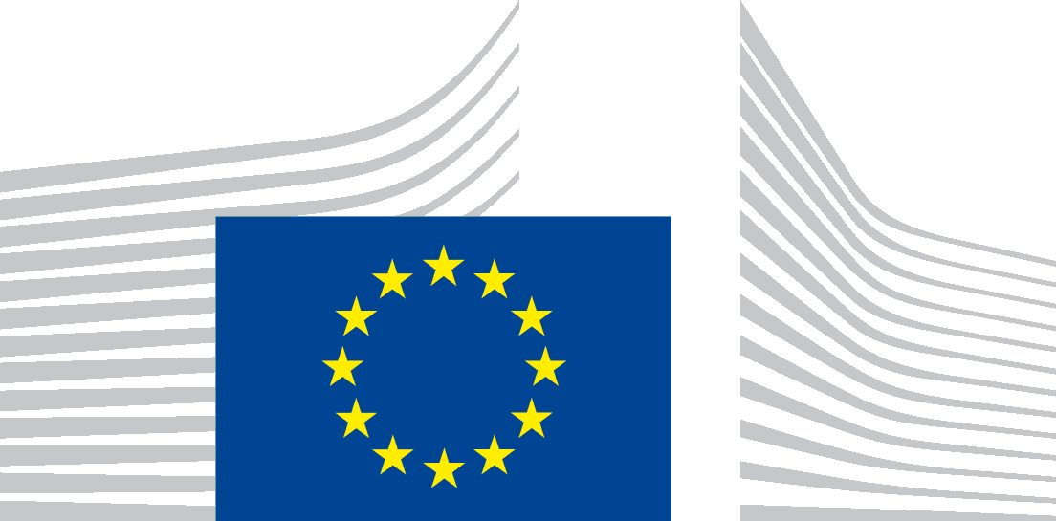 | EUROPEAN COMMISSION  DIRECTORATE-GENERAL JUSTICE and CONSUMERS  Directorate E: Consumers  Unit E.1 : Consumer Policy

Brussels, 1 March 2017

Conclusions and follow up actions from the Meeting of the European Consumer Consultative Group (ECCG) held on 22 February 2017

Dear Members,
Below you will find a list of follow-up actions as per items of the meeting agenda:

- ECCG Rules of Procedure
- The proposed ECCG Rules of Procedure were adopted.

- Clean Energy Package
- The Commission presented the consumer rights and interests entailed in the Clean Energy Package, divided into four main groups: better information, easier switching, renewables and self-generation, data protection and energy poverty. The Commission made clear that the consumer dimension of the Package depends very much on the discussion in the EU Parliament and in the Council.
- Consumer organisations generally welcomed the Package. They stressed the importance of enforcing consumer rights in case the Package will be delivered. They expressed willingness to contribute and to help the Commission in promoting the consumer rights in the negotiations on the Package.
- The group agreed to preparing a draft opinion with the help of the ECCG subgroup on Energy and it was agreed that BEUC would act as a rapporteur for the work. The opinion to be finalised and agreed by the main group before the Citizens' Energy Forum in London (30th -31st May).

- Empowerment of Consumers Organizations (Consumer Movement)
- A discussion on empowerment of consumer organisations was carried out, based on a presentation by Ms Kutin (Slovenia) on capacity-building efforts of Consumer Orgnisations in CESEE MS and on an intervention by Ms Goyens (BEUC) on the challenges of the financial sustainability of the consumer organisations. It was concluded that the different environments in the Member States require different approaches to the development of "business" plans of consumer organisations. For example, in some Member States consumers have been used to rely on the government to provide free of charge consumer information and in some Member States there are legal constraints in relation to certain kind of incomes for consumer organisations. The tradition of government funding of consumer organisations also differs in the Member States.
- To get an overview of the current situation in Member States, the Commission will circulate a short questionnaire to the organizations to take stock of the situations of the consumer movement in the Member States. This overview will help to design follow-up actions. Member organisations will be consulted on draft questions to be included into the questionnaire by the middle of March.

- The Role of Consumer Policy in the EU
- Based on presentations by Mr Schmitz (Luxembourg) and Ms Goyens (BEUC), Consumer organisations agreed that, in different ways and at different levels, the European Union framework, consumer aquis and relevant legislation in several sectors, have had an important role in the improvement of national consumer policy and legislation.
- They also agreed that implementation and enforcement of consumer law in Member States must be strengthened. Member organisations stressed the importance of the constant involvement of national consumer organizations in EU action, in particular on checking the implementation of directives at national level. The Commission agreed to consider organizing meetings taking this into account when it will be practically feasible and also, as in the past, thematic discussions on specific files. Consumer organizations and the Commission agreed to keep each other informed and updated as much as possible on respective files.
- Both the Commission and consumer organizations agreed that rebuilding trust of consumers in the European Union requires the EU to propose changes that matters for consumers in their daily life, such as roaming or passenger rights. Consumer Organisations would like to participate as actors of a positive change.
- Collaboration between the Commission and consumer organizations will be brought further by both sides in the framework of the ECCG and its meetings to support this ambition.. The Commission, based on the discussion in this meeting, will consider a follow-up to be given to it.

- Other issues
- It was agreed that the next meeting will take place on the 14th of June.
- Due to the start of the mandate of the current composition of the ECCG in August 2016, the deadline for the annual national reports was set for the 15th of September, covering the period from 1st September 2016 to 1st September 2017. The Commission will circulate a template and some examples of the previous reports closer to the reporting deadline.
- The Commission will circulate a list of the short state of play of consumer relevant ongoing files (including on collective redress).

